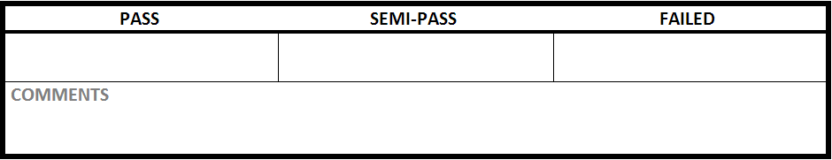

|  |  |
| --- | --- |
| Test Case #:ITM1.1 | Test Case Name: Create Item |
| System: Rec Warehouse | Subsystem:Item |
| Designed by: Rec Team | Design Date: October 2013 |
| Executed by: Nate Maurer | Execution Date: |

|  |
| --- |
| Short Description:Create a item with correct data |

|  |
| --- |
| Preconditions:at the main page with a new item to add |

|  |  |  |  |  |
| --- | --- | --- | --- | --- |
| Step | Action | Expected System Response | Pass/Fail | Comment |
| 1 | click ‘Item Management" | changes to the create item screen | Pass |  |
| 2 | enter ‘Garmin international’ into Vendor Name | displays "Garmin international’ in Vendor Name | Pass |  |
| 3 | enter ‘Nuvi’ into Product Line | displays Nuvi in Product Line | Pass |  |
| 4 | enter ‘322624’ into Vendor Id | displays ‘322624’ in Vendor Id | Pass |  |
| 5 | enter '458000001624' into Item UPC | displays '458000001624' in Item UPC | Pass |  |
| 6 | enter ‘Nuvi 3670 GPS’ into Item Name | displays ‘Nuvi 3670 GPS’ in Item Name | Pass |  |
| 7 | enter ‘095142’ into Legacy Item ID | displays ‘095142’ in Legacy Item ID | Pass |  |
| 8 | enter ‘budget Garmin GPS with lifetime maps.’ into item Description | displays ‘budget Garmin GPS with lifetime maps.’ in item Description | Pass |  |
| 9 | select ‘Automotive’ in Department | displays ‘Automotive’ in Department | Pass |  |
| 10 | select ‘GPS’ in category | displays ‘GPS’ in category | Pass |  |
| 11 | select 'Automotive GPS' in subcategory | displays 'Automotive GPS' in subcategory | Pass |  |
| 12 | enter ‘69.99’ into MSRP | displays 69.99 in MSRP | Pass |  |
| 13 | enter ‘59.99’ into sell price | displays ‘59.99’ into sell price | Pass |  |
| 14 | enter ‘12’ into restricted age | displays '12' in restricted age | Pass |  |
| 15 | select 'all' in Seasonal Code | displays 'all' in Seasonal Code | Pass |  |
| 16 | click Create New Item | displays a green confirmation message at the top of the page | Pass |  |

|  |
| --- |
| Postconditions: creates a item in the database with all information Pass |